Press Release

miriac® MPX-S32Z SoM for high-performance real-time applications

MicroSys SoM combines multi-core, real-time processing with extensive connectivity for multi-tenant, virtualized software integration in rugged applications.

Munich, Germany, April 11, 2024 – MicroSys Electronics GmbH has designed a miriac® SoM featuring an NXP® S32Z eight-core Arm® Cortex®-R52 real-time processor, a Cortex® M33 real-time coprocessor, a 25 GFLOP DSP/ML processor, up to 2 GB LPDDR4-RAM. With eight analog inputs and a wide variety of digital interfaces including QSPI and 2xGb Ethernet with TSN, the SoM gives engineers an early start to designing future systems.

Designed within the framework of the BAYChamp project to develop a future-proof integrated modular avionics platform publicly funded by the German state of Bavaria, the miriac® MPX-S32Z System-on-Module (SoM) is a powerful and versatile platform for future systems powering aerospace, automotive and mobile machinery applications.

Featuring the NXP® S32Z2 real-time processor with eight 600-1000 MHz Arm® Cortex®-R52 cores, a Lockstep Arm® Cortex®-M33 system manager core and a 25 GFLOP DSP/ML processor as well as up to 2 GB LPDDR4-RAM, the SoM combines multi-core, real-time processing with core-to-pin hardware virtualization and DSP/ML processing. It provides ample processing power for multi-tenant software integration. The SoM also includes a microcontroller for module management.

Despite its compact size of only 82 x 50 mm, the SoM maximizes the use of the vast processor IO capabilities without limiting the implementer. The module’s 310 pin MXM3 edge connector accommodates eight analog inputs and makes a wealth of interfaces available. These include 16 x CAN FD, 2 x CAN XL, 2 x FlexRay, 4 x LIN, SPI, JTAG and TRACE. A 512 Mb QSPI and two GbE LAN interfaces supporting the Time Sensitive Networking (TSN) standard for real-time data transmission allow for fast and secure communication.

miriac® System-on-Modules are application-ready platforms for NXP® processor technology. The Modules are "Made in Germany" and support all processor-integrated features with a comprehensive, perfectly matching functionally validated package.

Using the MicroSys SoM and tools from the ever-growing NXP and partner ecosystem, engineers can design and test the surrounding hardware as well as the software now to be market-ready as soon as the first S32Z2 devices are commercially available. As these are AEC-Q100 Grade 1 devices supporting up to -40 to 150 °C and come with a 15-year long-term availability guarantee, the miriac® MPX-S32Z SoM gives engineers a head start designing powerful as well as rugged systems with long, sustainable lifecycles.
Caption:
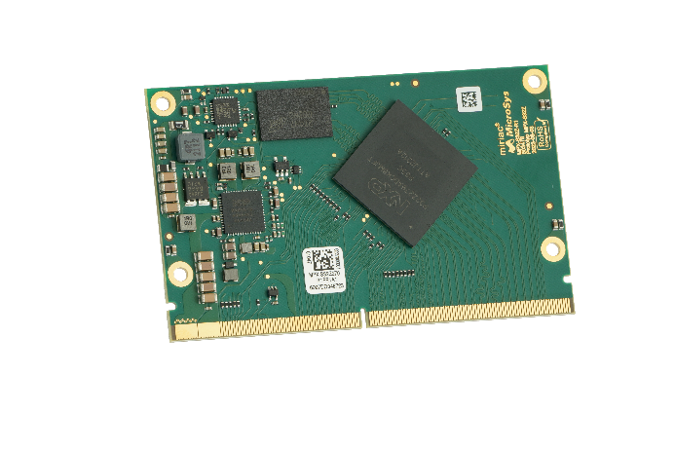
The miriac® MPX-S32Z System-on-Module (SoM) from MicroSys is a powerful and versatile platform for future systems powering aerospace, automotive and mobile machinery applications.

About MicroSys Electronics
MicroSys Electronics has been designing and developing embedded system solutions since 1975, is an NXP Gold Partner and widely integrates NXP’s S32 Automotive, Layerscape and QorIQ processor technology. Designs based on System-on-Modules (SoMs) are the strengths of this German company based in Sauerlach near Munich, with the portfolio ranging from application-ready SoMs and customer-specific carrier board designs to fully integrated systems. Application areas for these extremely rugged designs with long-term availability are primarily found in markets where safety standards in compliance with IEC 61508 are required, such as railway technology (EN 50155), aviation (DO-160), and mobile machinery (ISO 13849), as well as manufacturing robots (ISO 10218), control systems (IEC 62061), and drive systems (IEC 61800-5-2). Further application areas can be found in medical technology (IEC 60601), and in critical infrastructures like the nuclear sector (IEC 61513) or the process industry (IEC 61511). MicroSys works closely with its customers in all these industries to ensure that all of the specific applicable standards are fully met.
https://microsys.de/

All trademarks are the sole property of their respective owners.

Contact:
MicroSys Electronics GmbH
Ina Sophia Schindler, CEO
Muehlweg 1
82054 Sauerlach, Germany
Phone: +49 (8104) 801‐0
Web: http://www.microsys.de
E-Mail: info@microsys.de

