DS AUTOMOTION to showcase groundbreaking innovations at LogiMAT 2022:
Plannable Autonomy

Aside of ARNY, the new driverless counterbalanced forklift AGV, DS AUTOMOTION will showcase revolutionary software innovations in hall 2, booth D04, of the Stuttgart LogiMAT 2022 show. The new ARCOS vehicle software enables that premium manufacturer’s AGVs for fully autonomous navigation. With selectable degrees of autonomy, the extended DS NAVIOS AGV control software achieves a fine balance between greater freedom for more flexible applications and the high levels of reliability and efficiency required in industrial applications.

Agile Lifting Power
The LogiMAT 2022 show will see the first live appearance of ARNY, DS AUTOMOTION’s new driverless counterbalanced forklift AGV with lifting heights up to 8.5 m and payloads up to 2.5 t. ARNY can utilize all popular methods for navigating and operate using various kinds of batteries and charging concepts. ARNY features an extremely small turning circle so it can navigate in very narrow aisles.

Flexible and efficient
The ARCOS (Autonomous Robot Control & Operating System) vehicle software newly designed by DS AUTOMOTION engineers enables AGVs to navigate cooperatively and collaboratively, turning them into Autonomous Mobile Robots (AMR). The latest generation of the DS NAVIOS AGV control software from DS AUTOMOTION communicates via VDA 5050, providing an open and standardizes interface. It features DS AUTOMOTION’s novel approach of adjustable autonomy. It provides AGV systems with more flexibility while ensuring the high levels of reliability and efficiency required in industrial applications.

DS AUTOMOTION will be present in hall 2, booth D04.

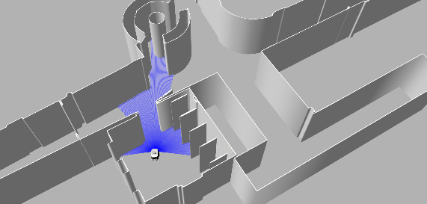 | Aside of ARNY, the new compact and agile, driverless counterbalanced forklift AGV, DS AUTOMOTION will showcase the interplay of the new ARCOS vehicle software and the extended DS NAVIOS AGV control software for cooperative and collaborative AMR navigation with selectable degrees of autonomy.  All images: DS AUTOMOTION
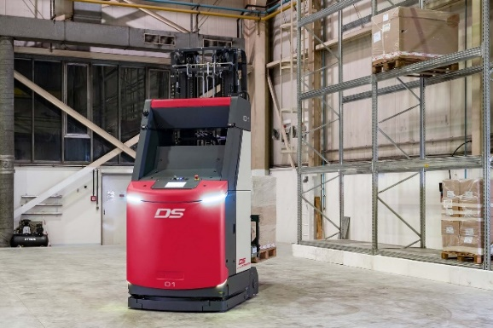

About DS AUTOMOTION
DS AUTOMOTION GmbH, headquartered in Linz, Austria, is a globally leading supplier of automated guided vehicle (AGV) transport systems and autonomous mobile robotics. Since 1984, the company has been specializing in development and production of automation solutions for various applications and industries. The company’s rich experiences from the development and production of more than 8,000 custom vehicles loops back into the development of standard products. The company’s more than 250 employees act globally, generating 96 percent of the revenues through export.
Find more information at www.ds-automotion.com.

For more information, visit www.ds-automotion.com.

